Harrison Dulgarian: How a Great Career Ended Too Soon

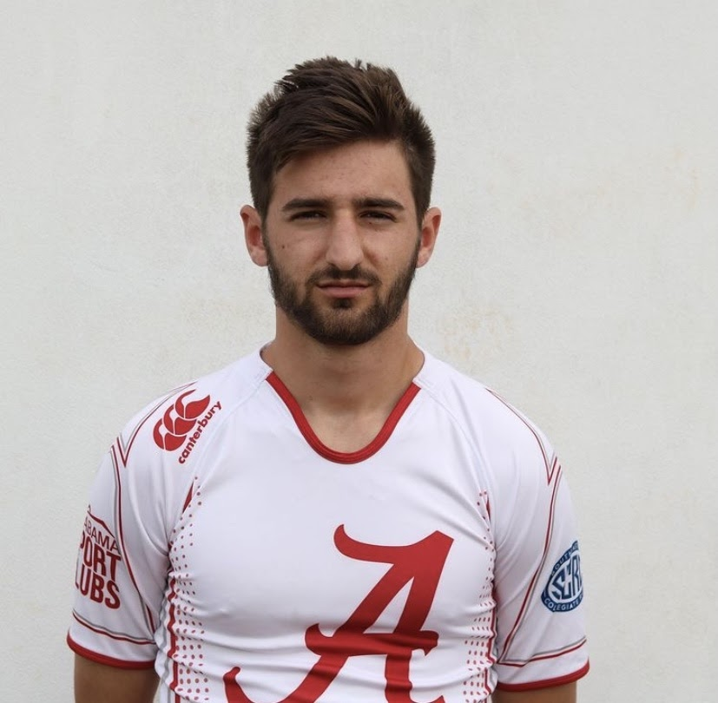
(Headshot of Harrison Dulgarian. Credit: alabamamensrugby)

Harrison Dulgarian is not only one of the most talented players on the University of Alabama Men’s rugby team, but he is also the most respected. Harry as he likes to be called, plays the scrum half position. This feature is about how large of an impact Harry had on the success of the Alabama Men’s rugby team and how it came to an unfortunate, sudden end.

Scrum half can be closely compared to playing quarterback because ball distribution and decision making are key to both positions. Scrum half is also referred to as scrummie or half back. After a tackle, the scrum half throws the ball out of a ruck, to the next closest teammate. The scrum half inserts the ball into the front of the scrum and throws it out once the ball reaches the back. It’s well known that this is the hardest position to play in rugby. “If he went down, we were all in trouble. No one can run an offense as well as Harry,” said captain Paulie Malito.
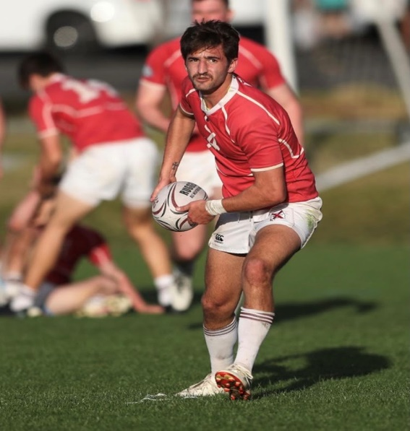
(Harrison Dulgarian passing the ball in pregame warmups. Credit: alabamamensrugby)

“The more I play the game, the more I feel comfortable making the correct decisions. Every year, I see my friends get better than the year before and that’s motivating to see,” said Malito. Harry has more experience playing rugby than anyone else on the team. The rugby knowledge that he possesses is invaluable to the chemistry of his teammates.

Harry was selected #2 Freshman Rugby player in all D1AA in 2017. He was awarded First Team S.C.R.C. as scrum half and was the second ranked scrummie in all D1AA in 2018. Not only is Harry a talented player, but he is also a gifted student as well. He has a 3.99 GPA and will be graduating college early due to credits he earned in high school.

Rugby isn’t very popular in the South because it is dominated by other sports like football, basketball, and baseball. Rugby is common in the Northeast region of the United States and the West coast in areas such as California and Utah. Alabama’s Men’s Rugby team is in the Southeastern Collegiate Rugby Conference(S.C.R C). Historically speaking, the conference is usually dominated by Tennessee, South Carolina, Kentucky, and Alabama. Out of the 12 teams in the entire conference, Alabama is one of 4 teams that are not on scholarship. How is it that Alabama can compete with other scholarship programs despite having none themselves? “The University itself is a melting pot of people from all over the country. We have guys on our team who played rugby their entire lives from opposite ends of the country. I don’t know how each of us ended up here, but we do the best we can with what we have to work with,” said Cole Bahan, current President of Alabama Men’s Rugby club.

In 2018, Alabama booked their ticket to the conference semifinals in Knoxville, Tennessee. It was a four-team tournament, win or go home. Alabama played Tennessee first followed by Kentucky playing South Carolina. Alabama’s team was led by Harry’s stellar play. He scored the game winning try off a 60-meter run to put Alabama within one point of the Tennessee lead, with less than a minute to full time. He scored on the far-right side of the field, making it a difficult kick for the conversion. Despite his exhaustion Harry wanted to take the kick.

The kicking trajectory was equivalent to a 40-yard field goal, not to mention with a steep angle as well. Harry took his time lining up for the kick because he knew the gravity of the situation. He stepped forward and drilled the ball dead on. The kick was good with little room to spare and just like that, Alabama beat Tennessee. The Tide were going to the conference finals for the first time since 2015. Harry was awarded player of the game and when I asked him about his performance, he attributed his, “God first and foremost. But, secondly, our team had better endurance and that was the key factor in the match,” said Dulgarian.

The next day Alabama played Kentucky in the championship match. The last time Crimson Tide won the S.C.R.C. was against the Wildcats three years prior. Every year since then, Kentucky has beaten Alabama to advance further into the conference playoffs. The game started off well with a 17-15 lead for the Tide at halftime. Going into the second half, it was a defensive slug fest with constant pressure from the back line. After a long defensive stand, Kentucky was awarded a penalty in the try zone which gave them 5 points. This call was highly questionable by the referee according to the players I spoke to. Just minutes later, the whistle was blown, game over. Alabama lost a heartbreaker to a rival after a questionable call from the referee. “I’ll admit it, I cried at the end of that game. We had worked so hard to get to the championship game and we should have won it,” said Dulgarian. Harry wanted a championship, but little did he know how peculiar his path would turn out. 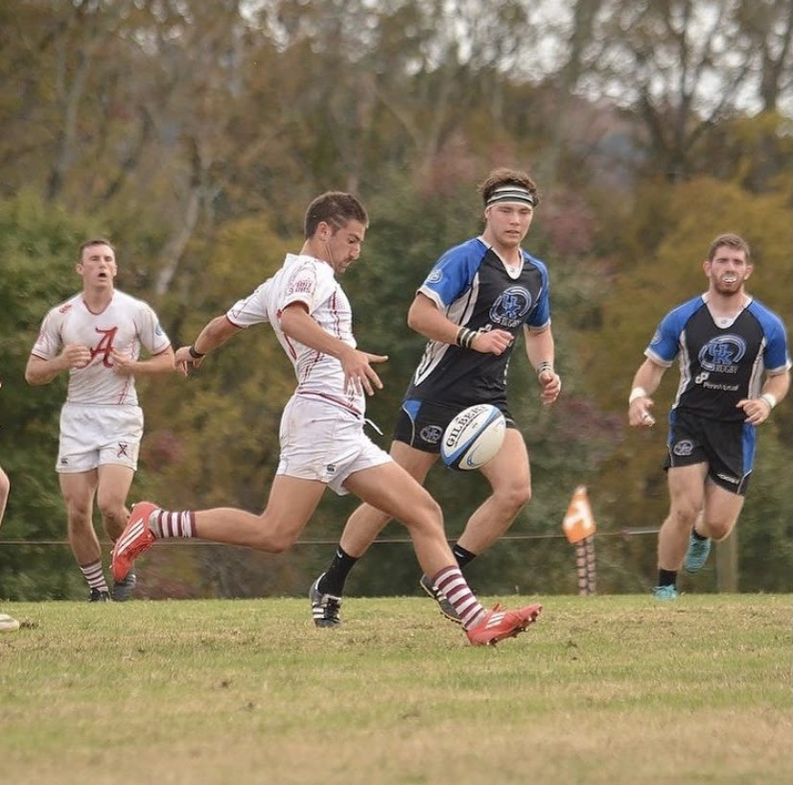
(Harrison Dulgarian kicking the ball against Kentucky in the conference finals. Credit: alabamamensrugby)

On February 27, 2020, the Alabama Men’s Rugby team flew to Los Angeles for the 2020 LA Sevens Invitational College Division Tournament. Because the rugby team is a club sport, the University of Alabama doesn’t provide financial support for the team’s activities. Harry organized the entire trip himself and even coordinated the traveling of the team from Tuscaloosa to LA and back. According to Harry, the rugby club has never traveled this far for a tournament, let alone how expensive it was for the players.

However, Harry convinced the team how significant this opportunity was for the club. Putting a non-scholarship team in the national spotlight to compete against highly competitive scholarship teams from around the country could be comparable to a David and Goliath type situation. After intense training and preparation, the Crimson Tide headed to LA to take on some of the country’s best sevens teams. The preliminary round went better than expected for the Crimson Tide. They went 4-0 in the tournament with wins against Northern Colorado, Northeastern, Mount Royal and Western Michigan.


(Dignity Health Sports Park during an MLS game. Credit: Bailey Holiver)

This secured a spot in the championship game, which was held in Dignity Health Sport Park, in Carson, CA. This stadium is also home of the NFL’s LA Chargers and the MLS’s LA Galaxy. Going into this game, nobody thought Alabama would be in the final round. "We certainly did not expect to make it all the way to (the) final," said Caleb Strum. For most people at the tournament, this was their first glimpse of Alabama rugby. The game plan was simple, stick to the system that got them here. The Tide were down 12-0 to New Mexico Highlands University in the championship match. However, after stellar performances by Caleb Strum, Mike Pikowski, and Harry Dulgarian, Alabama came back to win 19-12. "I feel this about all of the guys; we wouldn't have won without any of them. But Harrison's the guy who made the trip happen. He's the most humble guy and we couldn't have done it without him,” said Strum.
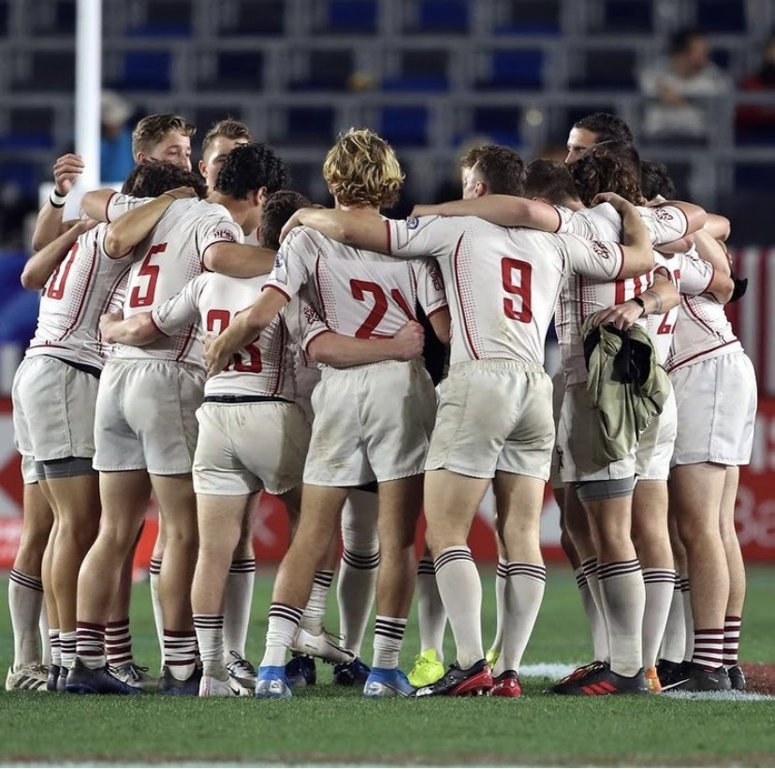
(The University of Alabama Men’s Rugby team in a pregame huddle before the final match in the LA Sevens Collegiate Tournament. Credit: lasevensrugby)

Goff Rugby, they interviewed the team following the match. After the tournament in LA the Crimson Tide had high hopes of finishing out as conference champions. Unfortunately, the Coronavirus put the entire world to a halt and ceased all group gatherings and preached social distancing. In response, the University of Alabama has cancelled the fall season for all club sports. This virus has affected all of us, but for Harry, he has a personal grudge against it. This fall 15s rugby season was supposed to be his last because he is graduating in December. Harry won’t have a senior season for the Alabama Rugby team. Unfortunately, he won’t be able to have one last hoorah as a player for the Crimson Tide. He had a spectacular career for the Crimson Tide and was even recognized as one of the best in the country.
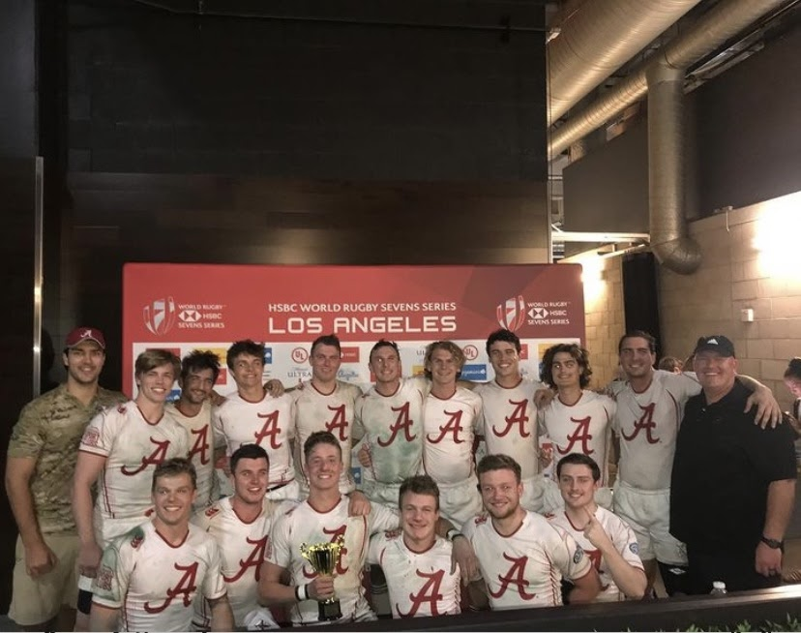
(The University of Alabama Men’s Rugby team posing with the championship trophy. Harrison Dulgarian is third from the left in the second row. Credit: alabamamensrugby)

Harry took his academic and athletic career very seriously and it set a positive example for his teammates. Harry will graduate from the University of Alabama with a degree in International Relations and recently, has earned his pilot’s license. After he graduates, Harry has a job lined up as a pilot for an aviation company in Northern California. He doesn’t have professional rugby aspirations even though he admitted, “That would be pretty cool. However, I need to take my career seriously,” said Dulgarian.

Sources:
Harrison Dulgarian (310) 975-9475
Cole Bahan (309) 846-8550
Caleb Strum (205) 495-4912
Paulie Malito (815) 272-1370

